**Installation and Setup for Telesis CIFX-EIP PC Cards**

**Overview**

Hardware Platform

The Telesis CIFX-EIP PC Card uses either the CIFX-50E PCI Express Card or the CIFX-90E Mini-PCI Express Card provided by Hilscher Communication Solutions. The card can be configured using software and drivers developed by Hilscher and provided on the Telesis CIFX-EIP Software Kit.

Ethernet/IP Output Assembly Instance 101

This output assembly, which is consumed by the card, consists of the following data items:

* Outputs: 3 bytes
* Message ID: 1 byte
* Message Type: 1 byte
* Message Data: up to 251 bytes

The card will retrieve the outputs from the fieldbus, and store it in its internal memory. Then, an application can request this output image from the card using the CIFX driver. The Message ID, Message Type, and Message Data are used in the Implicit Messaging Pass-Through Service.

Ethernet/IP Input Assembly Instance 100

This input assembly, which is produced by the card, consists of the following data items:

* Error Status: 3 bytes
* Machine Status: 4 bytes
* Inputs: 2 bytes
* Input: 1 byte
* Response Message ID 1 byte
* Response Message Type 1 byte
* Response Message ACK 1 byte
* Response Message Data up to 243 bytes

The card will receive the inputs from an application using the CIFX driver, and store it in its internal memory. Then, it will send this input image to the fieldbus. The Response Message ID, Response Message Type, Response Message ACK, and Response Message Data are used in the Implicit Messaging Pass-Through Service.

Custom Explicit Messaging Pass-Through Service

If the application chooses not to use the Implicit Pass-Through Service, then the application can use the Explicit Messaging Pass-Through Service by way of a custom Ethernet/IP service. In this case, the application will use the CIFX driver and the Ethernet/IP Adapter firmware in the card to register the service with the protocol stack. The vendor-specific information for this service is as follows:

* Service 0x45
* Class 0x64
* Instance 0x01
* Attribute Anything other than 0

In this case, the Master will send an explicit message to the card that contains the following data:

* Message ID: 1 byte
* Message Type: 1 byte
* Message Data: up to 251 bytes

Upon receiving the message, the card will pass this message to the application using the CIFX driver. After processing the message, the application will pass the response to the card using the CIFX driver, and the card will forward the response to the Master with the following data:

* Message ID: 1 byte
* Message Type: 1 byte
* Message ACK: 1 byte
* Message Response: up to 243 bytes

**CIFX Driver**

Driver Installation

In the Telesis CIFX-EIP Software Kit, double-click on **Communication-Solutions**. In the application window, click on **Driver, Software, and Tools**->**Install cifx/netJACK Device Driver**. Follow the on-screen prompts to install the CIFX driver. This driver is a software-first driver, which means that the card need not be installed in the PC to install the driver.

**SYCON.net Configuration and Setup for CIFX PC Cards**

Installation

In the Telesis CIFX-EIP Software Kit, double-click on **Communication-Solutions**. In the application window, click on **Install SYCON.net Configuration Software**, and follow the on-screen prompts to install the SYCON.net Configuration software package.

Configuration

From the Start Menu, run **SYCON.net** and acknowledge any sign-on screens to begin setup and configuration of the card.

1. Create a new project, and save the project by clicking **File->Save As**.
2. On the right side of the netDevice pane, browse to **EtherNet/IP->Gateway/Stand-Alone Slave**. Click and drag the **CIFX-RE/EIS** icon to the center of the netDevice pane as shown below. 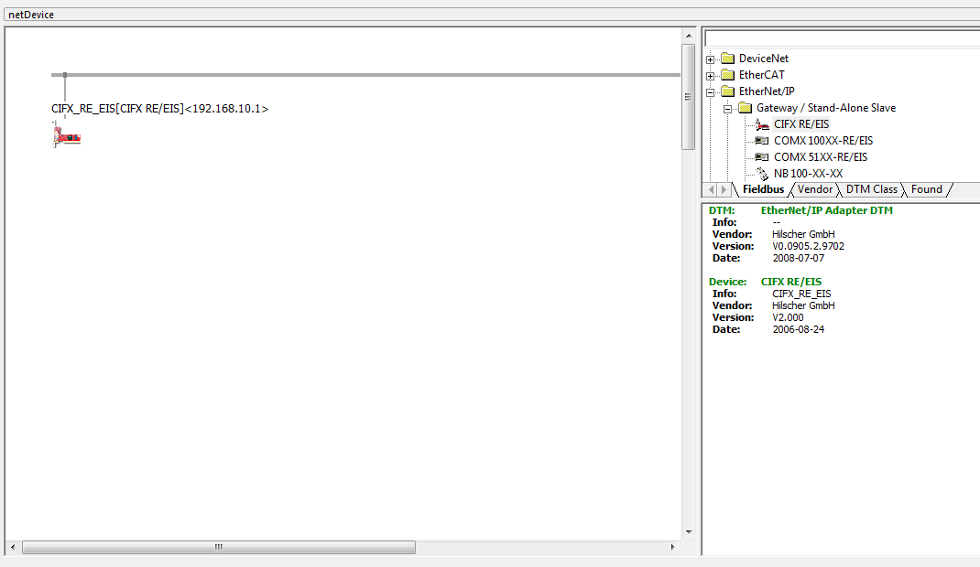
3. 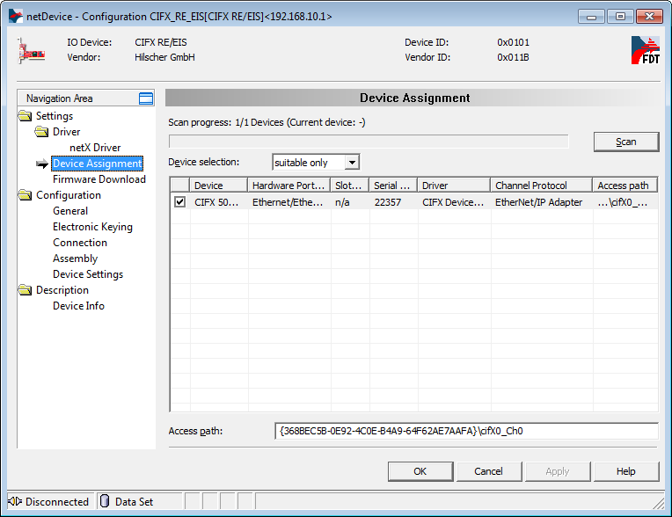Double-click on the device to open a Configuration window as shown to the right. In the Navigation Area, navigate to **Settings->Device Assignment** to display the Device Assignment view. Find the device, click its checkbox, and click **Apply**. This assigns the driver to the device.
4. 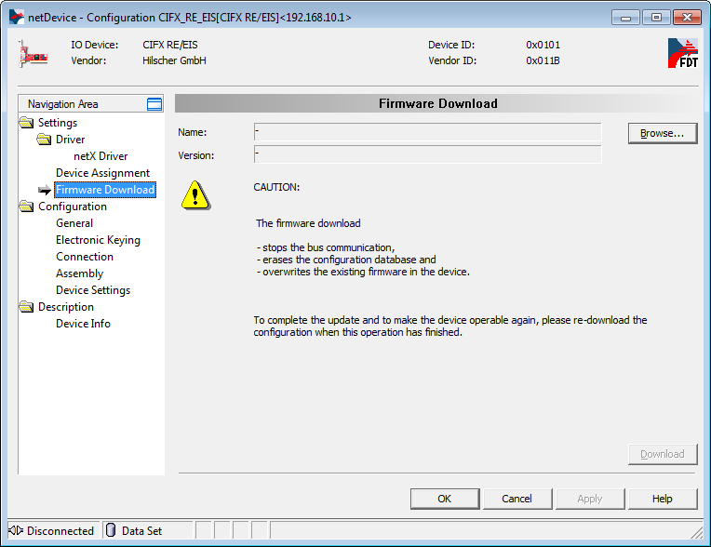In the Navigation Area of the Configuration window, navigate to **Settings->Firmware Download** to display the Firmware Download view as shown to the right. Click **Browse** and navigate to **Firmware->CIFX** in the Telesis CIFX-EIP Software Kit, and select the EtherNet/IP Adapter firmware. Once the firmware has been selected, click **Download** to download the new firmware to the device. This must be done before any configuration can be downloaded to the device. Once the download has completed, click **OK** to save changes.
5. Double-click on the device to open a Configuration window as shown to the right. In the Navigation Area, navigate to **Settings->Device Assignment** to display the Device Assignment view. Find the device, click its checkbox, and click **Apply**. This assigns the driver to the device.
6. 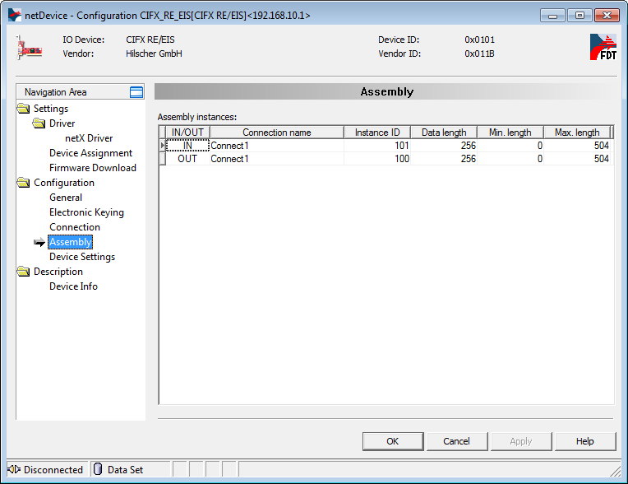In the Navigation Area of the Configuration window, navigate to **Configuration->Assembly** to display the Assembly view as shown to the right. For Telesis CIFX-EIP PC Cards, the data length of both I/O assemblies will be set to 256. Select the **Data length** field of each assembly and enter 256. Click **Apply** to save changes.
7. Refer to the Hilscher documentation included with the Telesis CIFX-EIP Software Kit for more information about the remaining Configuration views. Once the device configuration has been set in the software, click **OK** to close the Configuration window. Right-click on the device, and click **Download** to download the configuration to the device. Save any project changes.

**Application Setup**

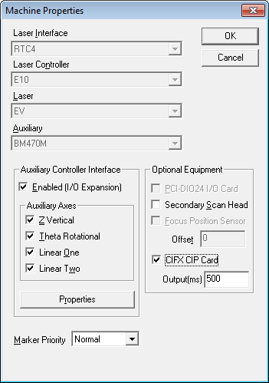Merlin II LS

The standard Merlin II LS software package (Telesis item# 47038) supports the Telesis CIFX-EIP PC Card beginning with version 9.00. To use the card, start Merlin and click **Setup->Level->Supervisor** to enter Supervisor mode. Then, click **Machine->Properties** to display the Machine Properties window as shown to the right. In the Optional Equipment section, click the **CIFX CIP Card** checkbox; this will enable the Output text box. This text box represents the interval in which Merlin will update outputs and machine status in the EtherNet/IP Input Assembly. Click **OK** to create an interface to the card. For additional information about the firmware in the card, click **Help->About Cifx** to display the window shown above. 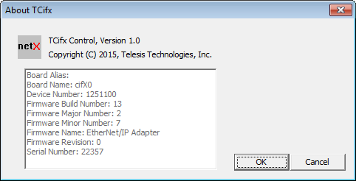 This window displays relevant information about the firmware that is currently loaded in the card. Of particular importance is the Firmware Name; in this case, EtherNet/IP Adapter. This information will be useful for interfacing Merlin to the card.

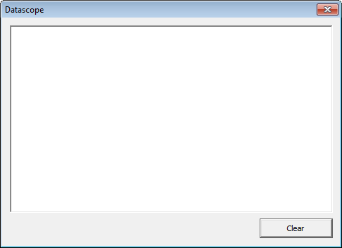To setup Merlin’s interface to the card, click **Setup->Cifx** from Supervisor mode. This displays CIFX property pages as shown below. The General Properties tab allows a Supervisor to configure properties that are not specific to any protocol. For the Telesis CIFX-EIP PC Cards, select **EtherNet/IP** as the protocol using the Protocol drop-down box. Note that this protocol should only be selected if the EtherNet/IP Adapter firmware is loaded in the card. This can be seen in the About window that is shown above. The Cyclic Poll Rate text box allows a Supervisor to designate the interval in which Merlin will poll the output image from the Output Assembly in the card. By default, this value is 500 ms. The EtherNet/IP tab allows a Supervisor to configure properties that are specific to the EtherNet/IP protocol. The Enable Pass-Through Service checkbox is used to determine whether the Implicit or Explicit Pass-Through Service will be used. If the box is checked, then the Implicit Pass-Through Service will be used. Otherwise, the Explicit Pass-Through Service will be used. The Maintenance tab allows a Supervisor to configure maintenance properties that are independent of any protocol. The Log File text box allows a Supervisor to choose a file that Implicit and Explicit Extended Protocol Messages will be logged to. The Datascope check box determines whether a Datascope dialog box will be displayed as shown above. If this dialog is displayed, then Implicit and Explicit Extended Protocol Messages will be displayed in this dialog.

|  |
| --- |
| **CIFX General Properties** |
| cid:image001.png@01D0F779.3F9A88A0  **CIFX EtherNet/IP Properties** |
| **CIFX Maintenance Properties** |

**Mapping of the EtherNet/IP I/O Assemblies**

Merlin II LS

* EtherNet/IP Output Assembly Instance 101

|  |  |
| --- | --- |
| **Byte Offset** | **Purpose** |
| 0 | Spare (16-23) |
| 1 | Outputs MSB (8-15)  .0 = Reserved  .1 = Reserved  .2 = Reserved  .3 = Reserved  .4 = Reserved  .5 = Reserved  .6 = Reserved  .7 = Reserved |
| 2 | Outputs LSB (0-7)  .0 = GO  .1 = ABORT  .2 = SELECT0  .3 = SELECT1  .4 = SELECT3  .5 = SELECT4 / ONLINE  .6 = Reserved  .7 = Reserved |
| 3 | Message ID |
| 4 | Message Type |
| 5 | Message Data |

* EtherNet/IP Input Assembly Instance 100

|  |  |
| --- | --- |
| **Byte Offset** | **Purpose** |
| 0 | Error Status Spare |
| 1 | Error Status MSB |
| 2 | Error Status LSB |
| 3 | Machine Status MSB  .0 = MACHINE FLY AUTO GO  .1 = MACHINE FLY TRIGGER LASER  .2 = MACHINE AXIS RESET  .3 =  .4 =  .5 =  .6 =  .7 = |
| **Byte Offset** | **Purpose** |
| 4 | Machine Status  .0 = MACHINE PREVIEW  .1 = MACHINE PREPOSITION  .2 = MACHINE INPUT  .3 = MACHINE SERIAL TOOL  .4 = MACHINE SELECTED  .5 = MACHINE PULSE  .6 = MACHINE FLY  .7 = MACHINE FLY TRIGGER |
| 5 | Machine Status  .0 = MACHINE TARGET  .1 = MACHINE HOMING  .2 = MACHINE PRINTING  .3 = MACHINE DRYRUN  .4 = MACHINE PAUSED  .5 = MACHINE PARKING  .6 = MACHINE BATCH  .7 = MACHINE REPEAT |
| 6 | Machine Status  .0 = MACHINE ABORTED  .1 =  .2 =  .3 =  .4 = MACHINE ONLINE  .5 =  .6 =  .7 = |
| 7 | Spare (8-15) |
| 8 | Inputs (0-7)  .0 = READY  .1 = DONE  .2 = PAUSED  .3 = SPARE1  .4 = SPARE2  .5 = SPARE3  .6 = Reserved  .7 = Reserved |
| 9 | Reserved |
| 10 | Response Message ID |
| 11 | Response Message Type |
| 12 | Response Message ACK or NAK |
| 13 | Response Message Data |